1. String Initialization & Memory
In Java, a String is an object that represents a sequence of characters. Unlike primitives, Strings are immutable—once created, their value cannot be changed.
Two Ways to Initialize:
- String Literal: String s = "Hello";
  - Stored in the String Constant Pool (SCP).
  - The String Constant Pool (SCP), also known simply as the string pool, is a special memory area within the Java heap memory where unique string literals are stored. Its primary purpose is to optimize memory usage and improve performance by ensuring that only one copy of each distinct string value exists in the JVM.
  - If another variable is created with the same literal, it points to the same memory location (saving memory).
- Using new Keyword: String s = new String("Hello");
  - Forces the creation of a new object in the heap memory, even if "Hello" already exists in the pool.

Code Example:
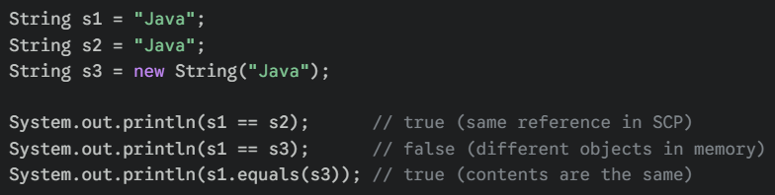Application: Memory optimization in large-scale applications where the same text (like "Success" or "Error") is reused thousands of times.
2. Essential String Methods
Java provides a rich library of methods to manipulate text. Since Strings are immutable, these methods return a new String rather than modifying the original.
Detailed Notes & Common Methods:
- length(): Returns the number of characters.
- charAt(int index): Returns the character at a specific position.
- equals(): Compares the content of string objects.
- == : It compares the reference of the object in the memory.
- concat(): concat() method joins two strings.
- substring(int start, int end): Extracts a portion of the string.
- contains(), startsWith(), endsWith(): Boolean checks for patterns.
- trim(): Removes leading and trailing whitespace.
Code Example:
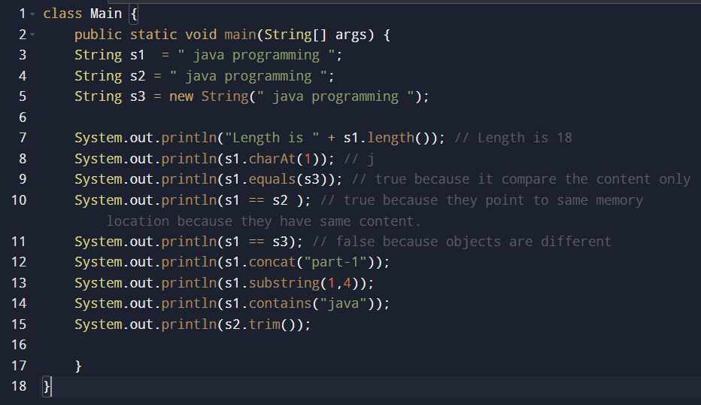
3. StringBuffer
StringBuffer is a peer class of String that provides much of the functionality of strings but is mutable. It was the original solution (introduced in JDK 1.0) for modifying text without creating constant new objects.
- Thread-Safe: Every method in StringBuffer is synchronized. This means if two different threads try to modify the same string at once, StringBuffer ensures they don't corrupt the data.
- Performance: Because it manages "locks" to ensure thread safety, it is slightly slower than its modern counterpart.
Code Example: StringBuffer
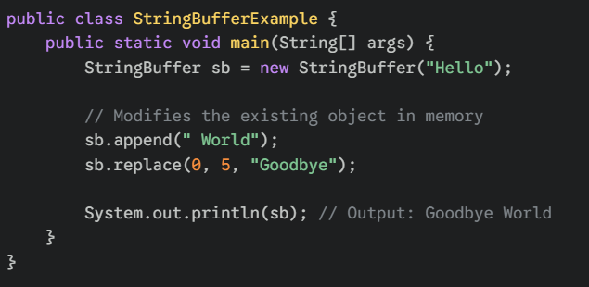

4. StringBuilder
StringBuilder was introduced in JDK 1.5. It is identical to StringBuffer in terms of API (the methods are the same), but it removes the synchronization.
- Not Thread-Safe: It does not use synchronization. If multiple threads access it simultaneously, it could lead to errors.
- High Performance: Because it doesn't have the overhead of thread locking, it is significantly faster than StringBuffer. It is the "default" choice for most developers today.
Code Example: StringBuilder
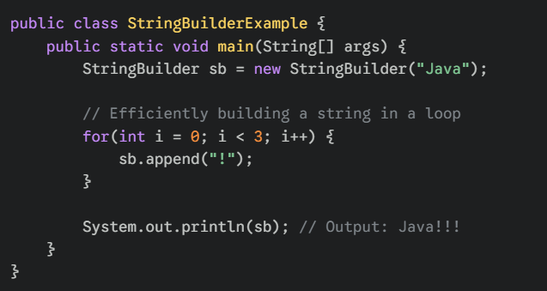
Key Differences at a Glance
Feature | StringBuffer | StringBuilder
Introduced | JDK 1.0 (Legacy) | JDK 1.5 (Modern)
Mutability | Mutable | Mutable
Thread Safety | Safe (Synchronized) | Not Safe (Non-synchronized)
Performance | Slower | Faster
Common Use | Multi-threaded environments | Single-threaded (Loops, logic)

